**Foundation SQL Module 5:**

Selecting & Filtering – Query reading

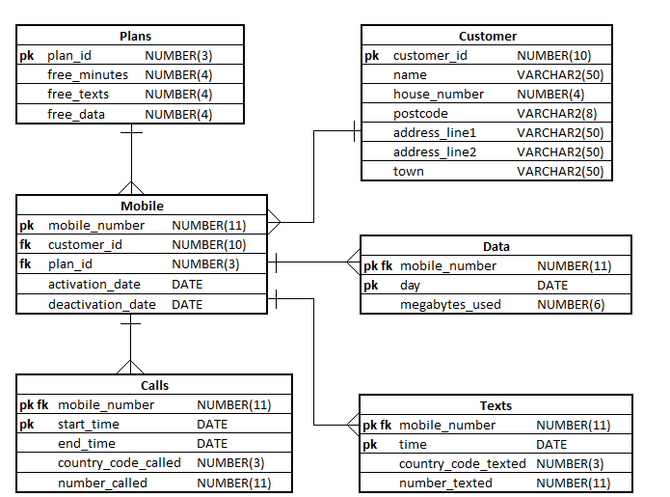

© FDM Group Ltd 2017. All Rights Reserved.

Any unauthorised reproduction or distribution in part  
or in whole will constitute an infringement of copyright.

**Describe in simple language what each of the following queries will return:**

|  |  |
| --- | --- |
| 1. SELECT mobile_number   FROM mobiles  WHERE plan_id = 2; | Display mobile numbers  That have plan 2 as their tariff |
| 1. SELECT mobile_number   FROM mobiles  WHERE  deactivation_date IS NOT NULL; | Display the mobile numbers  that have a date for deactivation |
| 1. SELECT mobile_number   FROM data  WHERE megabytes_used > 1000; | Display mobile numbers that  Have used over a 1000MB  Per day |
| 1. SELECT number_called   FROM calls  WHERE start_time LIKE SYSDATE  AND  mobile_number = 07526954758; | Display all the numbers called  by 07526954758 today |
| 1. SELECT number_texted   FROM texts  WHERE mobile_number = 07568953487  AND  TO_CHAR(time,’YY’) = TO_CHAR(SYSDATE,’YY’); | Lists the numbers texted  by 07568953487  This year (2021) |
| 1. SELECT number_texted   FROM texts  WHERE mobile_number = 07786486386  AND Time > SYSDATE – 0.5; | Displays number texted  Within the last 12 hours by  07786486386 |